Medical Domain Web Services (MDWS)
Version 2.0

C3-C1 Conversion Project
Systems Management Guide
(MWVS*2)



September 2011

Department of Veterans Affairs
Office of Information and Technology (OI&T)
Office of Enterprise Development (OED)

Revision History
Date | Revision | Description | Author
February 2010 | 1.0 | Initial version for v 2.0 | J Confer  L Harmon  K Bonner  C Beynon
May 2010 | 1.1 | Added content | J Confer
July 2010 |  | Changed dates | C Beynon
September 2010 |  | Changed dates to September | C Beynon
September 2010 | 1.2 | Clarified that this project is for a Class 1 conversion analysis | J Rogers
October 2010 | 1.2 | Changed dates to October | CBeynon
December 2010 | 1.2 | Changed dates to January 2011 | CBeynon
May 2011 | 1.3 | Changed dates to May 2011  Added (MWVS*2) namespace | CBeynon
June 2011 | 1.4 | Updated the SMG with comments from JM/Medora | CBeynon
July 2011 | 1.5 | Prepped for national release, ESE Checklist | CBeynon
September 2011 | 1.6 | Changed dates to September 2011 for September release | CBeynon

Table of Contents
Introduction 1
History 1
Orientation 4
MDWS 2.0 Overview 4
Document Overview 4
Additional Resources 4
MDWS Web Site 4
MDWS Documentation Set 5
Microsoft Internet Information Services 6.0 5
Database Information 6
Updating the PSSG Table 6
Updating the ZIPCodes Table 15
Security 24
MDWS Passwords 24
Setup and Configuration 25
MDWS Application Server Configuration 25
MSI Overview 25
MSI Physical Layout 25
MDWS Deployment Overview 26
MDWS Config Files 26
VhaSites.xml Format 27
IIS 6.0 Console 28
Overview 28
Console Navigation Tree 28
Server-specific Information 29
MDWS IIS Property Tabs 30
Troubleshooting MDWS 32
Uninstalling MDWS 32
Normal Procedures 32
Sample of an Error Message 33
Production Issue History 33
Potential Troubleshooting Steps 33
Failover MDWS Deployment 34
Automated Solution 34
Manual Solution 34
Symptoms, Diagnoses, and Possible Solutions 35
Glossary 36

Introduction
Medical Domain Web Services (MDWS) (pronounced meadows) is a suite of Service Oriented Architecture (SOA) middle-tier web services that exposes medical domain functionality, Medical Domain Objects (MDO). MDWS is equipped with the capacity to virtualize any legacy Veterans Health Information Systems and Technology Architecture (VistA) Remote Procedure Call (RPC) as a web service. A web service is an Application Programming Interface (API), which uses Simple Object Access Protocol (SOAP), the standardized protocol to communicate with subscribed client applications.

History
Historically, the Department of Veteran Affairs (VA) developers use a standard, 2-tier (client/server) architecture to develop applications, such as the Computerized Patient Record System (CPRS) and the Remote Procedure Call (RPC) Broker. CPRS communicates to VistA through the RPC Broker.
- Client - The top tier, or frontend, is the user interface (such as CPRS).
- Server - The bottom tier, or backend, is the data source (a single VistA system).

MDWS evolved from the field development that Joe Gillon created with MDO at Ann Arbor Veterans Affairs Medical Center (VAMC). MDO is easier to implement/utilize than the traditional methods of accessing the VistA Legacy systems (such as the RPC Broker).
- MDO is a library of data structures with behaviors in the medical domain. It is an improvement over the Delphi RPC Broker by building in business rules to free other developers from implementing the same requirements in each application.
- MDO is written in C# .NET.
- MDO is capable of accessing a VistA system, enabling it to communicate directly with any VistA system and use all the standard local CPRS RPCs.
- MDO is capable of multi-site queries, allowing it to read data from all relevant VistA systems in parallel in the time it takes to receive data from one system.

The browser-based Electronic Medical Record Graphical User Interface (EMR GUI)/VistAWeb (VW) was developed to demonstrate MDO. VW not only demonstrated MDO, but also featured patient-centric data rather than geo-centric data. VW became a national Class 1 (C1) application in 2005.

VistAWeb Services (VWS) was developed to take MDO to Java 2 Platform, Enterprise Edition (J2EE), when it was realized that most clients can consume SOAP web services. Trying to produce J2EE web services proved painful, error-prone and time consuming. However, writing web services in the top level domain .NET was simple. VWS became a C#.NET web service exposing a pure Java library. Several web services were produced under VWS, as development moved toward a new set of web services with a new MDO written in C#.

The new service, MDWS, exposes MDO and provides transparent multi-site accessibility, while enforcing business rules. Although MDWS is not yet certified as C1 software, MDWS received a waiver from Systems Engineering for the C1 deployment of Suicide Hotline.

The purpose behind this project is to evaluate the feasibility of and make recommendations to Enterprise Infrastructure Engineering (EIE) and VA management about taking the MDWS service to a Class 1 status. As a Class 1 service, MDWS will be fully certified, nationally released and supported by the Office of Enterprise Development.

MDWS will be the catalyst to make several VA mission critical systems operational in addressing compliance with VA requirements and White House/DHS mandates.

- Healthcare-Associated Infection & Influenza Surveillance System (HAIISS) program tools
- Electronic Surveillance System for the Early Notification of Community-based Epidemics (ESSENCE)
- QcPathfinder
- Bed Management Solutions (BMS) and other web-based applications

The current object set in MDWS focuses primarily on clinical information. Future development efforts may include other patient administrative areas, financial areas, etc. Much of the medical data comes from VistA,
- where data domain objects, such as Allergy, Medication, LabResult, etc., are created from the results of one or more VistA RPCs.
- where data comes from a relational source, the objects are created from recordsets.
- where data comes from XML sources the objects are created by parsing the Document Object Model (DOM).

Using MDO’s data structures and behaviors, MDWS interacts with a variety of data sources. MDWS queries several VA data sources for clinical data.
- All the VistA systems
- Master Patient Index (MPI)
- Structured Query Language (SQL)
- Extensible Markup Language (XML)
- Health Level 7 (HL7)
- Some Planning System Support Group (PSSG) sources

MDWS is used by a variety of field-developed products and is a component of several notable C1 efforts implemented across the Enterprise.
- Adverse Drug Reaction
http://vhaannscm1.v11.med.va.gov/trac/medora/wiki/Clients/ADR
- Apollo (CPRS Re-engineering (AViVA)
http://trac.medora.va.gov/web/wiki/Projects/Apollo
- Athena
http://trac.medora.va.gov/web/wiki/Clients/Athena
- BHIE
http://trac.medora.va.gov/web/wiki/Clients/BHI
- Chronic Disease Management
http://trac.medora.va.gov/web/wiki/Clients/CDM

- Crisis Center (web service behind Suicide Hotline and Homeless Hotline)
http://medora.sharepoint.med.va.gov/sites/crisiscenter/default.aspx
- Diversions
http://medora.sharepoint.med.va.gov/sites/diversions/default.aspx
- Electrophysiology Reporting
Ann Arbor
- EMERSE
http://trac.medora.va.gov/web/wiki/Clients/EMERSE
- MOVE
http://www.move.va.gov/Default.asp
- MyHealtheVet
http://www.myhealth.va.gov/
- Mynapin (used in demonstrations)
3TUhttp://www.kabotintl.com/products.php?ProdCatID=7U3T
- National Utilization Management Integration (NUMI)
http://medora.sharepoint.med.va.gov/sites/utilizationmgt/default.aspx
- PatientFinder
http://medora.sharepoint.med.va.gov/sites/PatientFinder/default.aspx
- Traumatic Brain Injury
http://trac.medora.va.gov/web/wiki/Clients/TBI

Orientation

MDWS 2.0 Overview
The Medical Domain Web Services (MDWS) 2.0 is a middleware service that provides data services to other internal VA applications. It is written in C#, uses the Microsoft 2.0 .NET Framework, and runs on Microsoft Internet Information Services 6.0. It allows applications written in any language to access specific data resources through its external SOAP interface.

MDWS consists of external web methods, a set of data access objects for its resources termed Medical Data Objects (MDO), and a local SQL Server Database for logging and configuration tables.
- The external web methods adhere to SOAP and are defined by a WSDL that changes as little as possible. When the WSDL changes, so do the client applications dependent upon it.
- The MDO contain the data access and business rules. The objects connect to various data sources and return patient data.
- The SQL Server 2005 Database requires periodic updates to incorporate zip code and geographic data that MDWS requires.

Document Overview
This manual provides information on the management of MDWS 2.0 database and application server(s). It contains detailed information on .NET application server management, institution files, security, logging, and troubleshooting. Its intended audience includes server administrators and specialists at VHA hosting facilities like the intended C1 hosting at AITC.

The installation and maintenance instructions presented here assume the use of Windows as the client operating system. MDWS 2.0 does not support any flavor of *nix and is a Microsoft only platform.
- Terminology
The terms site and VISN are used interchangeably to refer to VHA sites; however, while all VISNs are considered sites, there are some sites that are not a VISN.
- Text Conventions
File names and directory names are set off from other text using bold font (e.g., config.xml). Bold is also used to indicate GUI elements, such as tab, field, and button names (e.g., press Delete).

Additional Resources

MDWS Web Site
The MDWS website summarizes MDWS architecture and functionality and presents status updates: http://medora.sharepoint.med.va.gov/sites/mdws/default.aspx

MDWS Developer
Joel Mewton – Ann Arbor VAMC

MDWS Documentation Set
The following documents are provided in the MDWS 2.0 documentation set:

- MDWS 2.0 Installation Guide: Provides detailed instructions for setting up, installing, and configuring the MDWS 2.0 application and database on Windows 2003 Server. Its intended audience includes server administrators and IT specialists, and C# application developers.
- MDWS 2.0 Systems Management Guide: Contains detailed information on IIS 6.0 application server management, institution files, security, logging, and troubleshooting.
- MDWS 2.0 Developer’s Guide: Contains detailed information about workstation setup, build procedures, institution files, subscribed applications, facades, and other information pertinent to developers learning the MDWS application.
- MDWS 2.0 Release Notes: Lists all new features included in each MDWS 2.0 release.

Microsoft Internet Information Services 6.0
MDWS 2.0 was tested and is supported on Microsoft IIS 6.0 only. Microsoft product documentation is found at the following website:
http://technet.microsoft.com/en-us/windowsserver/default.aspx.

Database Information

Updating the PSSG Table
If the Planning Systems Support Group (PSSG) data requires updating:
- Obtain the PSSG data file from the link Complete zip code extract at
http://vaww.pssg.med.va.gov/PSSG/search_zipcode4.html
- Save the file to a local drive.
Note: The exact filename varies, because the group that provides the file updates it.
Currently, the format is ZIP_mm_yyyy.
- In the database tree view, follow the path: Databases>mdws_test>Tables>dbo PSSG
- To drop the PSSG table (or delete), select Script Table as, select DROP To, and select New Query Editor Window.
- The Query Editor window displays.
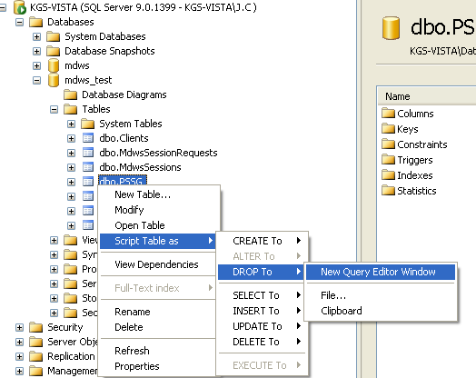
Screen capture of a Server database tree
mapping to New Query Editor Window

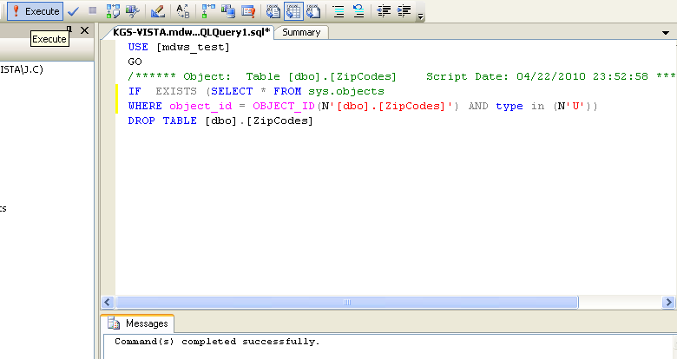
Screen capture of an Execute reply to a query
- In the database tree view, select mdws_test, Tasks, and Import Data…
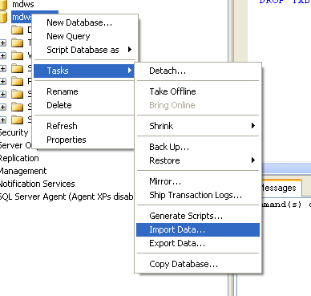
Screen capture of a Server database tree
mapping to Import Data…

- Open the SQL Server Import and Export Wizard.
- On the Choose a Data Source window from the Data source drop-down text box, select Flat File Source.
- To locate the File name of the downloaded file, click Browse.
- In the Format section, select the Column names in the first data row check box.
- Click Next.
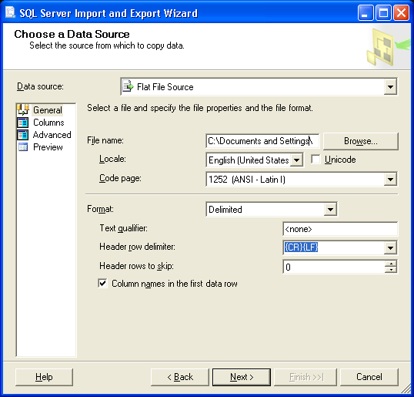
Screen capture of the SQL Server Import and Export Wizard window
Choose a Data Source

- On the Choose a Destination window from the Destination drop-down text box, select SQL Native Client.
- Confirm that the Server name and Database are appropriate.
- In the Authentication section, confirm the Use Windows Authentication radio button is selected.
- Click Next.
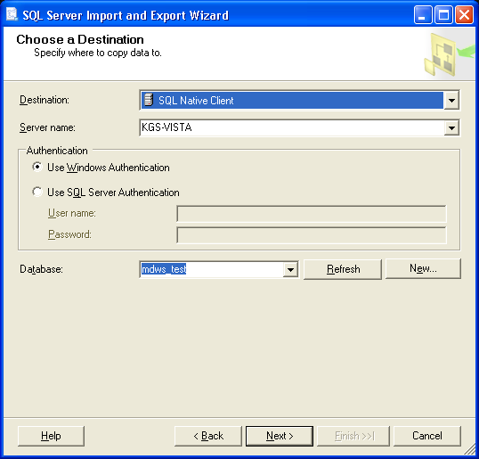
Screen capture of the SQL Server Import and Export Wizard window
Choose a Destination

- On the Select Source Tables and Views window, rename the Destination table to PSSG and click Next.
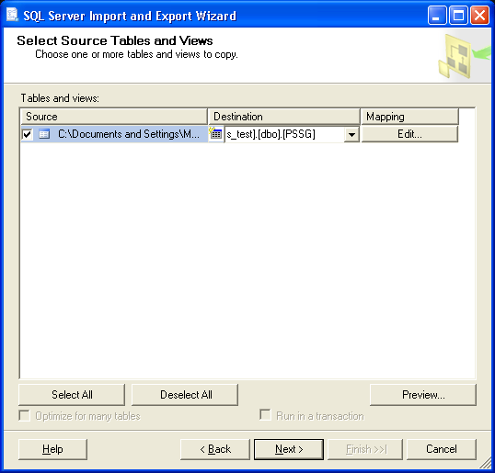
Screen capture of the SQL Server Import and Export Wizard window
Select Source Tables and Views

- On the Save and Execute Package window, select the Execute immediately check box and click Next.
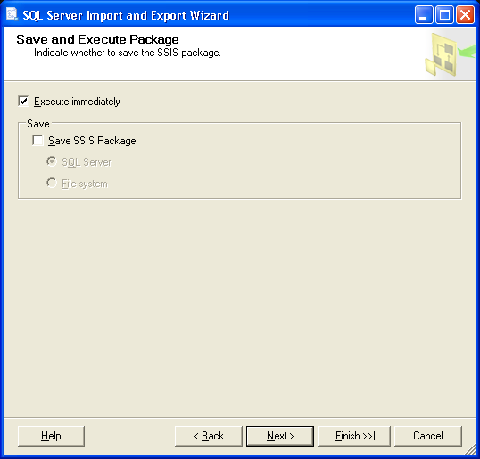
Screen capture of the SQL Server Import and Export Wizard window
Save and Execute Package

- On the Complete the Wizard window, review the source/destination locations and click Finish.
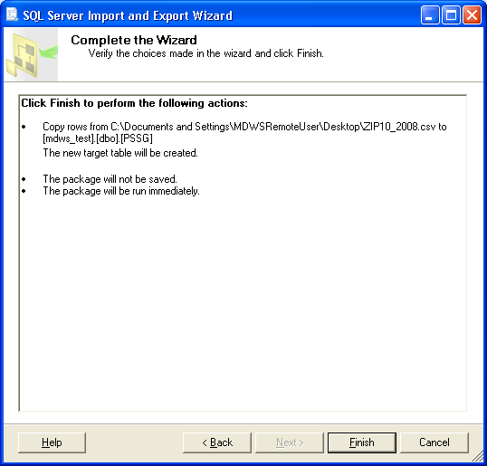
Screen capture of the SQL Server Import and Export Wizard window
Complete the Wizard

- With successful execution, Success displays, all steps complete.
Click Close.
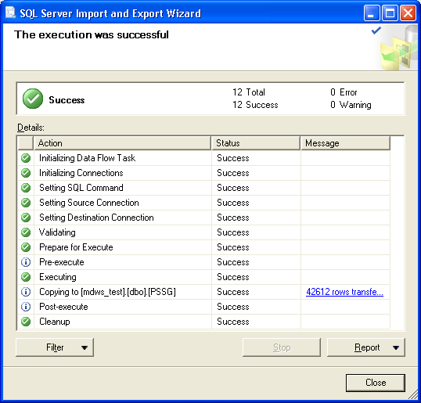
Screen capture of the SQL Server Import and Export Wizard window
The execution was successful

- In the database tree view, verify the dbo.PSSG table displays.
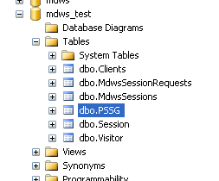
Screen capture of a Server database tree

Updating the ZIPCodes Table
Note: MDWS uses a zip code database from a paid subscription to ZIPCodeDownload.
- If Class 1 support needs the subscription, contact the MDWS development team for the file.
- The file may be in an Excel or Access database, if so, alter the following steps to account for the different file format.
If the zip code data requires updating:
- Obtain the update for the zip code data file from the source, ZIPCodeDownload at
www.ZIPCodeDownload.com
- Save the file to a local drive.
- In the database tree view, follow the path: Databases>mdws_test>Tables>dbo PSSG
- To drop the ZIPCodes table (or delete), select Script Table as, select DROP To, and select New Query Editor Window.
- The Query Editor window displays.
Screen capture of a Server database tree
mapping to New Query Editor Window

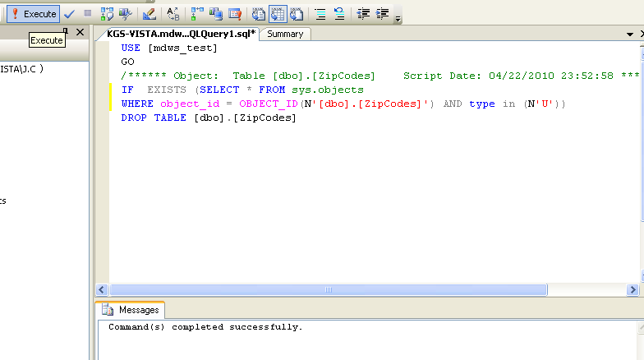
Screen capture of an Execute reply to a query
- In the database tree view, select mdws_test, Tasks, and Import Data…
Screen capture of a Server database tree
mapping to Import Data…

- Open the SQL Server Import and Export Wizard.
- On the Choose a Data Source window from the Data source drop-down text box, select Microsoft Access.
- To locate the File name of the downloaded file, click Browse.
- Click Next.
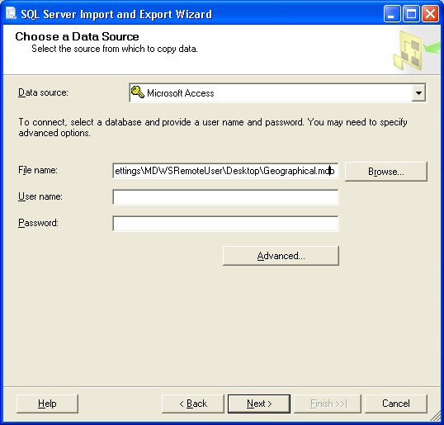
Screen capture of the SQL Server Import and Export Wizard window
Choose a Data Source

- On the Choose a Destination window from the Destination drop-down text box, select SQL Native Client.
- Confirm that the Server name and Database are appropriate.
- In the Authentication section, confirm the Use Windows Authentication radio button is selected.
- Click Next.
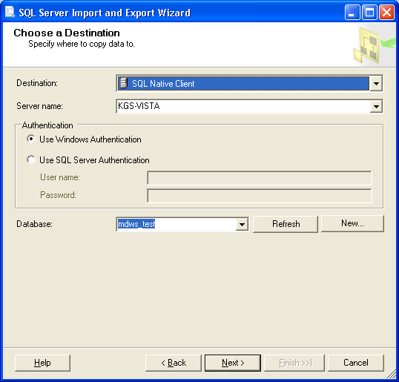
Screen capture of the SQL Server Import and Export Wizard window
Choose a Destination

- On the Specify Table Copy or Query window, select the Copy data from the existing tables or views in the source database radio button and click Next.
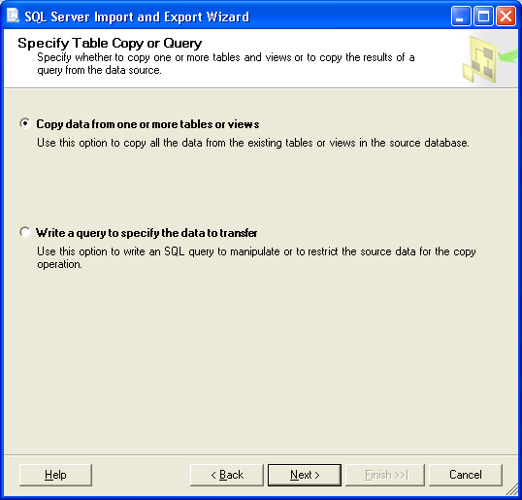
Screen capture of the SQL Server Import and Export Wizard window
Specify Table Copy or Query

- On the Select Source Tables and Views window, select the source table, ZIPCodes check box and click Next.
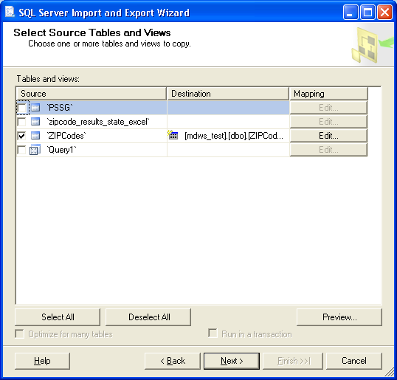
Screen capture of the SQL Server Import and Export Wizard window
Select Source Tables and Views

- On the Save and Execute Package window, select the Execute immediately check box and click Next.
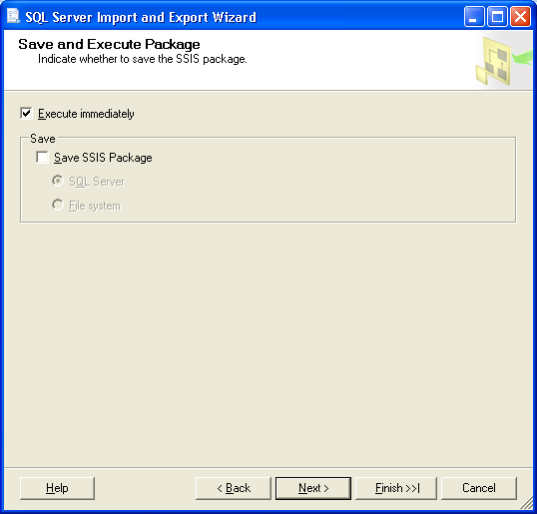
Screen capture of the SQL Server Import and Export Wizard window
Save and Execute Package

- On the Complete the Wizard window, review the source/target tables and click Finish.
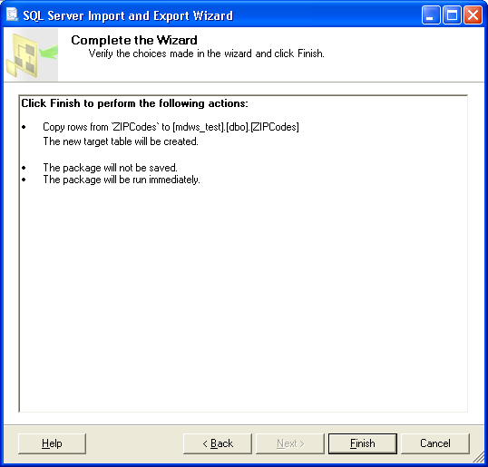
Screen capture of the SQL Server Import and Export Wizard window
Complete the Wizard

- With successful transfer, Success displays, all steps complete.
Click Close.
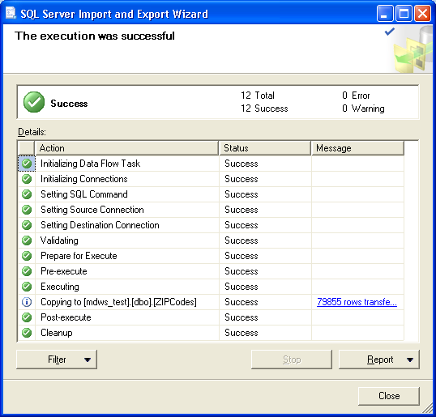
Screen capture of the SQL Server Import and Export Wizard window
The execution was successful
- In the database tree view, verify the dbo.ZIPCodes table displays with data.
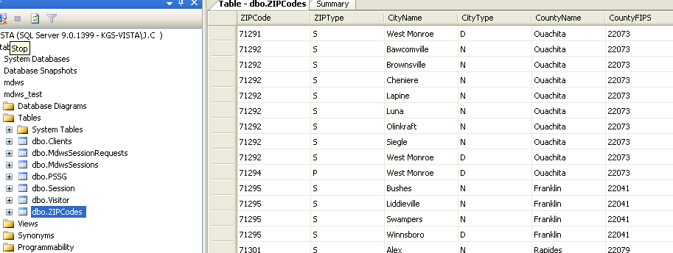
Screen capture of a Server database tree
Table – dbo.ZIPCodes tab

Security

MDWS Passwords
There are a couple of passwords for the MDWS system stored in plain text on the application server in a configuration file in the Resources/Conf directory. It is important to limit access to this directory.
Note: A future version of MDWS may encrypt these passwords inside the MDWS local database.
File with sensitive passwords:
mdws.conf

Setup and Configuration

MDWS Application Server Configuration

MSI Overview
MDWS application will be distributed in a .msi file (Microsoft Installer file) that contains everything needed to install and run the application.

MSI Physical Layout
The contents of the installed MDWS deployment package are as follows:

(root) MDWS web service definitions:
- EmrSvc
- CallService
- MhvService
- NumiService
bin\ .dll libraries:
- mdo.dll
- mdws.dll
- log4net.dll
- other supporting .dll

css\ Cascading Style Sheets:
- jquerty.treeview
- screen

images\ Images for dashboard page.

js\ JavaScript for dashboard page.

obj\ Debugging objects.
Resources\conf MDWS.conf configuration file

resources\lib\ Supporting application files.

resources\xml\ Site configuration files
-VhaSites
-TestVhaSites
-Other files per façade

MDWS Deployment Overview
For each site you want your MDWS instance to connect to, first make sure MDWS exists in one of the /resource/xml/*sites.xml files. The mdws.conf file contains the configuration information for each façade indicating which façade to point to the files of multiple sites. It is easy to change a single façade towards another (e.g., test) system by changing its entry in the configuration file.

The web.config contains configuration information specific to the application server. The connection information for MDWS resides in the local database. A login will be created for the database and this is where the user and password are defined.

For a server already set up with a working MDWS instance, the basic, high-level steps to deploy a new minor version of MDWS are as follows:
- Obtain the deployment package.
- Shut down IIS.
- Copy the deployment package over the existing websites folder.
- Use the MDWS test page to test links to all sites.
Note: This feature may still be in development.
- Update the MDWS database with new Zip Code and PSSG data, if applicable.
- Ensure any temporary .NET cache files are deleted.

The configurable settings for deployment of any MDWS instance are contained in the following locations:
- /resources/xml/*.xml
contains xml definitions of data sources, both VHA sites and others
- /resources/conf/mdws.conf
contains application server-specific definitions, including database connection information

MDWS Config Files
MDWS web services are broken up into façades. Façades control the selection of web methods to which an application has access. Each façade’s data sources can be controlled independently through the mdws.conf file. The Administration Console provides an interface for editing the mdws.conf file.

VhaSites.xml Format

<?xml version="1.0" encoding="UTF-8"?>
<VhaVisnTable xmlns=http://med.va.gov/vistaweb/sitesTable
xmlns:xsi=http://www.w3.org/2001/XMLSchema-instance
xsi:schemaLocation="http://med.va.gov/vistaweb/sitesTable VhaSites.xsd">
<VhaVisn name="VA New England Health Care System" ID="1">
<VhaSite name="Togus, ME" ID="402" moniker="TOG">
<DataSource modality="HIS" protocol="VISTA" source="VISTA.TOGUS.MED.VA.GOV"
status="active" port="19215"/>
</VhaSite>
</VhaVisn>
<VhaVisn name="MPI" ID="500">
<VhaSite name="MPI" ID="500" moniker="MPI">
<DataSource protocol="HL7" modality="MPI" source="MPI-AUSTIN.MED.VA.GOV"
status="active" port="5500" />
</VhaSite>
</VhaVisn>
</VhaVisnTable>

Note: Although each tag is VhaVisn and VhaSite, consider VISN as a Region descriptor for VISNs and a placeholder for non-VISN sources.
Tag | Field | Description
VhaVisn | name | Region ID text string
 | ID | Region ID integer
VhaSite | name | City, State Abbreviation
 | ID | Site ID
 | moniker | Site Abbreviation
DataSource | modality
 | protocol | Represents the communication protocol of the data source
 | source | URL of data source
 | status | Active or inactive
 | port | Port number of data source

IIS 6.0 Console

Overview
MDWS is managed using the Internet Information Services (IIS) 6.0 Microsoft Management Console (MMC).

To launch the IIS console,
Click Start->All Programs->Administrative Tools->Internet Information Services

Console Navigation Tree
The IIS console displays the installation branch, probably called/ named mdws_zzz, in the standard console navigation tree.
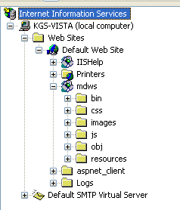
Screen capture of a Web Service database tree

Server-specific Information
Under the Web Sites node, the navigation tree displays one node for each MDWS instance in your application server. You can use these nodes to display information about MDWS deployments on each instance of the application. Because deployments are per server, deployment and status information may vary between servers.

Click a web site node and all the files associated with that site’s root directory display on the left side.
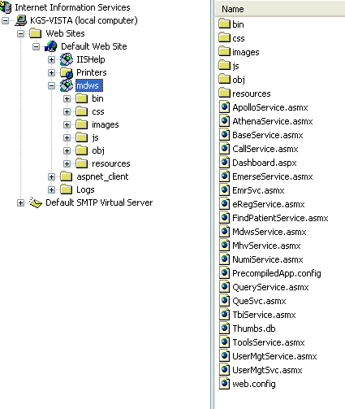
Screen capture of a Web Service database tree
Review MDWS installation

MDWS IIS Property Tabs
The information provided on the Properties tabs are for the non-default value tabs. The HTTP Headers, Custom Errors, and Documents tabs do not change.
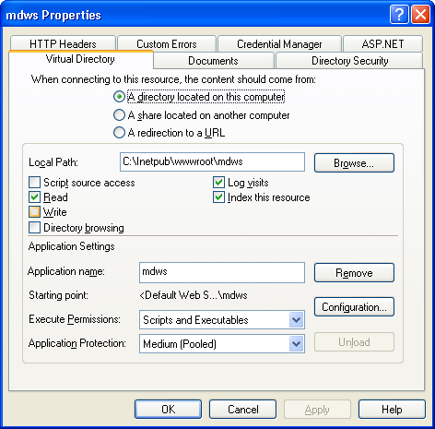
Screen capture of the mdws Properties window
Virtual Directory tab

Use the Authentication Methods information to verify the configuration of your web site(s).
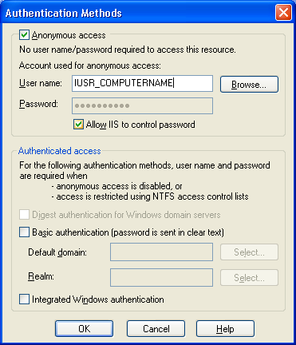
Screen capture of the Authentication Methods window

Troubleshooting MDWS

Uninstalling MDWS
- Click Start.
- Select Control Panel.
- Double-click Add or Remove Programs.
- Select MDWS.
- Click Remove.
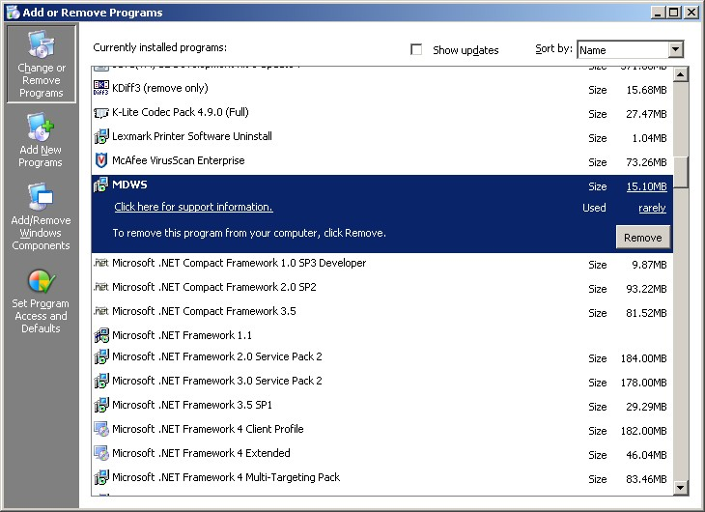
Control Panel>Add or Remove Programs

Normal Procedures
In general, to troubleshoot any problem, check the following sources:
- Browse to the local web services and make sure the Web Service Definition Language (WSDL) displays.
- Run the connection test page.

Sample of an Error Message
from MDWS to a requesting client application

<?xml version="1.0" encoding="utf-8" ?>
- <TaggedInpatientStayArray xmlns:xsi="http://www.w3.org/2001/XMLSchema-instance" xmlns:xsd="http://www.w3.org/2001/XMLSchema" xmlns="http://mdws.medora.va.gov/EmrSvc">
- <fault>
<type />
<message>There are no open connections</message>
<stackTrace />
<suggestion />
</fault>
<count>0</count>
</TaggedInpatientStayArray>

Production Issue History
MDWS has never had a production problem. MDWS shared an application pool at the C3 level with VistAWeb. Problems with the VistAWeb application caused a brief loss of connectivity for MDWS clients, until IIS was restarted.

Future productions issues are to be added to this document in the following table.

Date | Cause | Resolution

Potential Troubleshooting Steps
- In IIS, recycle the application pool in which MDWS resides.
- Restart IIS.
- Look for server events or server changes (anti-virus, group policies, etc.).

Failover MDWS Deployment
The client application(s) are responsible for pointing to a failover MDWS deployment and is not directly related to restoring a failed MDWS instance. The client can accomplish the failover in two ways: automated and manual.

Automated Solution
The automated solution is more complex from a software development standpoint, but has the advantage of being a near instantaneous resolution to a primary MDWS failure.

In an automated failover environment, when the primary endpoint no longer responds to requests, the client application switches from the primary well known MDWS endpoint to a well known backup or failover MDWS endpoint.
- It is imperative the client application support team is made aware a switch was made to a backup service.
- The client application developer must architect this notification into their software.

Manual Solution
In a manual failover environment, when the primary well known MDWS endpoint becomes unavailable,
the client application developer must manually modify their code or configuration files.
- The client application support team can be made aware of the failure automatically by including code that notifies the necessary personnel when the primary MDWS instance becomes unavailable.
- The client application support team usually settles on the simplest solution, which is to wait for users to report the failure. Then the support team begins troubleshooting, determines the failure is MDWS related, and points the client application to a well-known failover endpoint.

Symptoms, Diagnoses, and Possible Solutions
Symptom
MDWS WSDL not viewable locally
http://localhost/mdws/CallService.asmx
404 Page Not Found
Diagnoses and Solutions
IIS Default web site configuration likely incorrect
Symptom
This room left blank intentionally for future solutions
Diagnoses and Solutions
This room left blank intentionally for future solutions
Symptom
This room left blank intentionally for future solutions
Diagnoses and Solutions
This room left blank intentionally for future solutions
Symptom
This room left blank intentionally for future solutions
Diagnoses and Solutions
This room left blank intentionally for future solutions
Symptom
This room left blank intentionally for future solutions
Diagnoses and Solutions
This room left blank intentionally for future solutions
Symptom
This room left blank intentionally for future solutions
Diagnoses and Solutions
This room left blank intentionally for future solutions
Symptom
This room left blank intentionally for future solutions
Diagnoses and Solutions
This room left blank intentionally for future solutions
Symptom
This room left blank intentionally for future solutions
Diagnoses and Solutions
This room left blank intentionally for future solutions

Glossary
Term | Definition
AITC | Austin Information Technology Center
AViVA | A Virtual Instance of VistA Architecture
BHIE | Bi-directional Health Information Exchange
BMS | Bed Management Solutions
Caché | An ‘M’ based product (by InterSystems) which has been selected as the next generation VistA platform
CAPRI | Compensation and Pension Records Interchange
C1 | Class 1
C3 | Class 3
CCOW | Clinical Context Object Workgroup
Client Applications | Client applications can be written in Delphi. Visual Basic, C#, HTML/Javascript, PHP, etc.
COM | Component Object Model
Connectivity | Connectivity provides connection to the Master Patient Index (MPI), Structured Query Language (SQL) and Extensible Markup Language (XML).
COTS | Commercial Off the Shelf
CPRS | Computerized Patient Record System
DAO | Data Access Objects
DFN | Data File Number  A patient’s local identifier, the internal entry number in file #2
DHS | Department of Homeland Security
DICOM | Digital Imaging and Communication in Medicine
DUZ | A user’s local identifier, the internal entry number in file #200
EIE | Enterprise Infrastructure Engineering
ESSENCE | Electronic Surveillance System for the Early Notification of Community-based Epidemics
Façade | A set of useable features made available for applications of a certain type. Each façade is a partial class composed of methods from multiple source libraries combined in a logical grouping for the consumer type (e.g., Patient, Provider, Util)
FIPS | Federal Information Processing Standard
GOTS | Government Off The Shelf
GUI | Graphical User Interface
HAIISS | Healthcare Associated Infection and Influenza Surveillance System
HDR | Health Data Repository
HL7 | Health Level 7
ICD | International Classification of Diseases
ICN | The patient’s national identifier, Integration Control Number
IDE | Integrated Development Environment
IEN | Internal Entry Number
J2EE | Java 2 Platform, Enterprise Edition defines the standard for developing multitier enterprise applications
MDO | Medical Domain Objects  MDO is the middle-tier SOA used by MDWS to access multiple VistA sites without further credentialing, which works entirely through existing Remote Procedure Calls (RPCs)
MDWS | Medical Domain Web Services
MPI | Master Patient Index
MRI | Magnetic Resonance Imaging
MSI | Microsoft Installer (file)
MWSV | NameSpace assigned to Medical Domain Web Services (MDWS) by DBA
.NET | The Microsoft .NET Framework is a software framework that can be installed on computers running Microsoft Windows operating systems
NOK | Next Of Kin
NUMI | National Utilization Management Integration
OEF | Operation Enduring Freedom
OIF | Operation Iraqi Freedom
PHR | Patient Health Re cord
PSSG | Planning System Support Group
RPC | Remote Procedure Call
RSD | Requirements Specification Document
SIA | Security Integration Agreement
SMTP | Simple Mail Transfer Protocol
SOA | Service Oriented Architecture is a flexible set of design principles used during the phases of systems development and integration. A deployed SOA-based architecture will provide a loosely integrated suite of services that can be used within multiple business domains.
SOAP | Server Oriented Architecture Protocol
SQL | Structured Query Language
TIU | Text Integration Utility
UDDI | Universal Description, Discovery and Integration  A registry that enables a developer to shop for MDWS pre-fabricated web services
VA | Department of Veterans Affairs
VAMC | Department of Veterans Affairs Medical Center
VHA | Veterans Health Administration
VistA | Veterans Health Information Systems and Technology Architecture  An enterprise-wide information system built around an electronic health record used throughout the Department of Veterans Affairs medical system.
VW | VistA Web
VWS | VistA Web Services
WSDL | Web Service Description Language (WSDL) is a document that provides a common language to describe:  - what the web service does  - what functionality it can provide  - what data it can deliver  A developer can click WSDL and generate the code automatically.
XML | Extensible Markup Language

